IP address of a particular domain (guvi.in) and CPU/memory usage of my server:

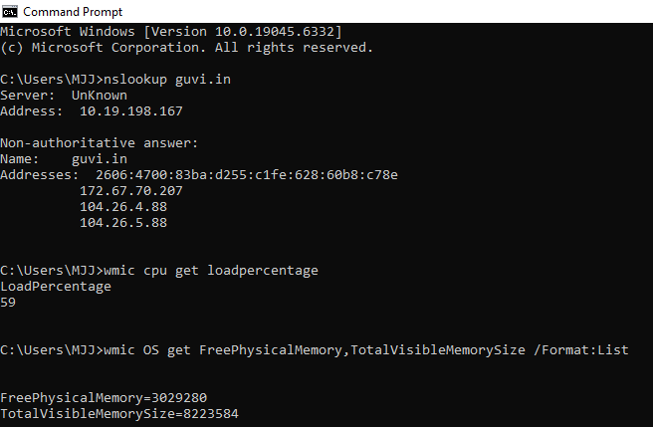

Test the connectivity between 2 nodes:

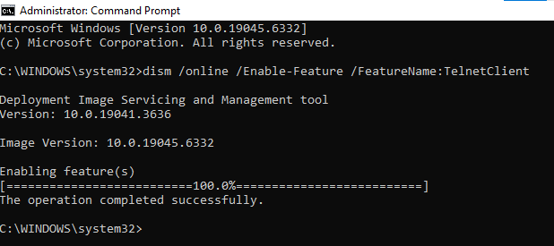

I have deployed an application in guvi.com:9000, and logs show my app is running, but I’m unable to view the page

